GFTADs for Europe

5- year Action Plan

for the period 2023 - 2027

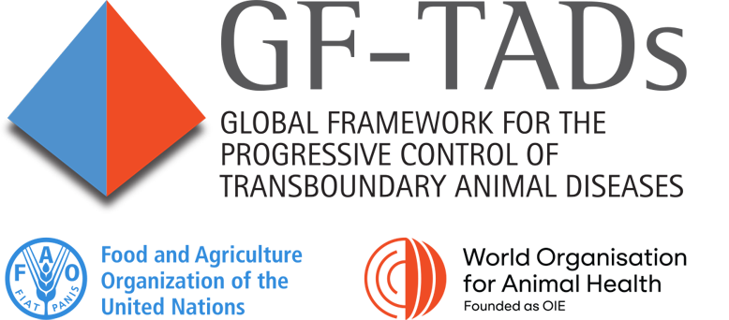

Introduction

The Global Framework for the Progressive Control of Transboundary Animal Diseases (GF-TADs), launched in 2004 is a joint initiative of FAO and WOAH to achieve the prevention and control of transboundary animal diseases (TADs) and in particular to address their regional and global dimensions. The initiative is built on experience showing that progress in controlling TADs at country level is not likely to be successful and sustainable unless the efforts are part of a coordinated regional approach or embedded into supra-national frameworks.
The GF-TADs for Europe - the regional branch of the GF-TADs for the European region according to WOAH delineation - was established in 2005 with a view to responding to increasingly frequent regional crises. It encourages the creation of regional alliances and partnerships and the definition of a common vision and subsequent action plans for the control of priority TADs in the region. The GF-TADs for Europe encompasses 53 European members, including Western Europe, South East Europe, Eastern Europe and Central Asia.
This Second Action Plan of the GF-TADs for Europe was developed building on the work previously done on the first Action Plan approved during the 5th Regional Steering Committee (RSC) meeting in 2013 and is based on the structure laid out in the global GF-TADs Strategy for 2021-2025 published in 2021.
This Action Plan was first presented to members of the RSC by an email consultation before the 10th RSC in October 2022, adopted after an e-consultation procedure and then officially endorsed by the RSC in an electronic procedure.
This document describes, the objectives and the implementation mechanisms of the GF-TADs for Europe Action Plan covering the period 2023 – 2027. The Priority Diseases presented in this regional Action Plan take account of the global ones as agreed by the Global Steering Committee of GF-TADs and therefore, quoting the work done at global level, this is a living document and it should be noted that new or rising concerns, such as the emergence or re-emergence of a transboundary animal disease that may occur at regional level, will be considered for incorporation during the implementation period.

Scope and framework

TADs prioritization facilitated / coordinated

The Action Plan addresses the transboundary animal diseases that have qualified as ‘priority’ for the region, namely:
- African Swine Fever (ASF)
- Lumpy Skin Disease (LSD)
- Rabies
- Foot and Mouth Disease (FMD)
- Highly Pathogenic Avian Influenza (HPAI)
- Peste des Petits Ruminants (PPR)
Taking from the eight diseases agreed as priority diseases during the RSC 6 in 2016, the six listed above are considered to be the current main priorities in Europe for the regional Action Plan covering the period 2023 - 2027. They also in general match the current global list of priority diseases.
The main efforts against Classical Swine Fever (CSF) over the past two decades have allowed countries to benefit from a much-improved situation, and it is therefore suggested at this stage to withdraw CSF from the list of main priorities (also considering that the focus on ASF will also contribute to prevention and early detection of CSF). Brucellosis is withdrawn because despite its infectious nature, brucellosis is not a transboundary animal disease in the sense its control can be achieved without a strong coordination across countries so GF-TADs is not necessarily the best mechanism, and given its important zoonotic component it needs to be primarily addressed under quadripartite framework.
Therefore, on the following diseases, it is essential to elaborate a full-fledged regional control strategy:
- ASF, which now occurs in domestic and / or feral pig populations of several countries in Europe and adjacent countries, needs the vigilance and mobilization of the whole region. The Standing Group of Experts on African swine fever in Europe under the GF-TADs umbrella (SGE ASF) was set up in 2014, aiming at building up a closer cooperation among countries affected by ASF at Chief Veterinary Officer (CVO) and expert level and thereby addressing the prevention, control and eradication efforts based on science and best practice in a more collaborative and harmonized manner across Europe,
- LSD, with the objective of strengthening mid-term regional cooperation and regional dialogue on LSD control. In July 2016, the first Standing Group of Experts on LSD in South-East Europe (SGE LSD) was created and met focusing on the control and eradication of the disease that had recently been introduced in South-East Europe through a harmonized mass vaccination strategy in affected and at-risk countries. Today, LSD in South-East Europe has been brought under control, and a reevaluation of the geographical scope of regional efforts towards Central Asia has been agreed,
- Rabies is still the most important zoonosis in terms of numbers of human deaths worldwide despite being entirely preventable. It has been successfully eradicated from large parts of Western Europe since the 1980s, however wildlife rabies remains present in other sub-regions and represents a constant challenge for ongoing eradication efforts. Experience has shown how crucial a coordinated (sub-)regional approach is on achieving eradication of rabies in wildlife (the predominant form in Europe). For this reason, in 2019, a new Standing Group of Experts on Rabies in Europe (SGE RAB) was created. The main objective of this Standing Group of Experts is to coordinate the oral rabies vaccination activities in wild carnivores with the overall goal to accelerate the eradication of rabies in Europe, primarily in the Balkan sub-region. Action on dog mediated rabies is coordinated through the quadripartite mechanism,
- FMD, given the strong emphasis at global level with the FAO-WOAH global control strategy endorsed in June 2012 is an important topic for cooperation in the region. Risks of incursion from neighboring countries remain in free countries and efforts remain necessary to control the disease and reach or regain free status in Central Asia,
- HPAI, for its economic impact in the region and because of its zoonotic potential, and the recent evolution of its epidemiology in Europe both in wild birds and in poultry, triggers the need to improve existing coordination mechanisms especially on surveillance throughout the different parts of the region and inter-regionally for early detection in wild birds and poultry, for monitoring the evolution in the characteristics of the virus and to improve regional approaches to prevention and outbreak control.
- PPR, given the strong priority of the Global eradication programme aimed at eradicating the disease by 2030, and the presence of the disease in Central Asia, needs to be fully integrated in the regional plan of action.
The Action Plan also integrates the regional component of strategies addressed at global level under the GF-TADs mechanism (Rinderpest post eradication activities, FMD global control strategies).
The Action Plan is flexible enough to address new or rising concerns (emergence or re-emergence of a transboundary animal disease, which would become a regional priority).
Example Activities Proposed | Verify regularly during RSC that priority TADs match the priorities of the different sub-regions
 | In case of emerging disease, consider if GF-TADs should be involved as coordination mechanism

Regional and sub-regional TADs control activities are formulated in alignment with global and regional strategies

Considering the list of regional priority diseases above, it must be underlined that epizootic situations vary for some diseases in the European region, and that local or sub-regional focus can differ from the overarching regional one.
To this end, it is important to identify sub-regional priorities, and to develop sub-regional planning for the fight against transboundary animal diseases whenever necessary. This can include:
- Creating or maintaining tools specifically for TADs of sub-regional importance (SGEs, Roadmaps, Regional Advisory Groups (RAGs) can address sub-regional issues with groups of countries directly affected or threatened by relevant TADs),
- Encouraging sub-regions to actively exchange with adjacent regions wherever TADs control makes coordination across regions relevant,
- Support to formulate relevant (sub-)regional strategy when necessary (for example, LSD in Central Asia).
These strategies can have a degree of autonomy at sub-regional level but must be approved by the President of the RSC, who will chair the relevant meetings whenever possible.
Example Activities proposed: | Develop or update (sub-)regional strategies or roadmaps for each of the priority TADs, based on existing frameworks at global level (ASF, FMD, PPR, and others such as HPAI when developed) and provide inputs to global frameworks
 | In the absence of formulated global strategies (Rabies for oral vaccination of wildlife, LSD, HPAI until global strategy is being developed), consolidate recommendations taking into account best practices and experience at national or sub-regional level, and international standards

Mechanisms for harmonized / coordinated planning are established

Coordinated planning is important to avoid overlapping of activities as well as a complete lack of activities in priority areas. Therefore,
- all partners must agree on a shared approach; this consensus-based approach is demanding but necessary to build understanding and acceptance of the importance of common goals. Consensus is built inside groups of experts and Delegates, along with trust and transparency on who intends to do what,

- there are specific coordination mechanisms; this is necessary to keep the dynamics and ensure adequate and timely interaction between members of the RSC. Coordination happens on two levels:

  - Working groups including the RAGs and Standing Groups of Experts, where proposals are discussed, and recommendations made for the region or sub-region,
  - Between groups, the mechanism of coordination is facilitated by the Secretariat in close coordination with the President of the RSC. The Secretariat is in charge of following the calendar of events, drafting reports, and organizing meetings working groups, such as the ones mentioned above and the roadmap mechanisms,

- the governance bodies of the regional GF-TADs monitor the implementation of the Action Plan; the governance is essential in setting the direction of action, discussing priorities, amending the Action Plan or list of priority diseases as needed, and assessing the results. This is the task of the Regional Steering Committee.
Example Activities proposed: | Consolidate workplans of GF-TADs partners on 12-24 months rolling basis, identifying responsibilities and GF-TADs labeling opportunities.
 | Organise follow-up and regular update of workplans.

Tools and actions

Capacity gaps are identified and priorities for capacity building are addressed

FAO and WOAH, along with relevant regional partners, provide the tools and expertise to identify gaps, needs, strengths and opportunities at regional and national level, including:
- WOAH OIE Tool for the Evaluation of Performance of Veterinary Services (PVS) missions in domains linked to the main TADs, FAO SET missions (surveillance evaluation tool) and FAO lab mapping tool (LMT),
- Country missions can also help identifying the main gaps related to one of the priority diseases, such as joint FAO/WOAH Emergency Management Centre (EMC) country missions, Standing Group of Experts country missions or EUVET (European Union Veterinary Emergency team) country missions.
Self-assessment tools are used where available. The correct description and weighting of these gaps and needs is a very important step in the prioritization of regional actions. In addition, donor organizations should be encouraged to take into account the identified gaps and needs in a holistic way.

Example Activities proposed: | consolidate information on capacity assessment activities implemented in or by members (e.g. tool, focus, country, year of implementation) and share the information
 | coordinate implementation of capacity assessment activities including country’s missions according to the evolution of epidemiological situation
 | organize capacity building activities to address the priority gaps identified

Multi-disciplinary planning for the preparedness. prevention and control of priority TADs is strengthened

Addressing the challenges TADs present in Europe needs covering of different aspects to achieve success. These include:
- Technical, political, communication and organization aspects sustain each other and must be addressed together,
- When relevant, activities should be planned together with other priorities in the wider sphere of livestock farming and food production, so that they can be supported by different actors from different sectors, as in the case of the PPR eradication strategy,
- Proper connection between science and policy should be facilitated, ensuring policy makers and risk managers provide clear indications on applied research priorities and make the best use of research outcomes
- Moreover, it is important to address the wildlife component of TADs, as relevant.
.
The result of this planning is described in the coordinated activities planning, disease control milestones (Annex 1) and logical framework (Annex 2).
Example Activities proposed: | Listing all of the disciplines to take into account; and invite relevant stakeholders to SGEs
Continue / strenghten collaboration with hunters for work related to wildlife collaboration (ASF, HPAI).
Develop value chain analysis for certain pig/poultry production involving socio economists, Associate anthropologist for certain communication campaign towards small producers, etc.

Providing harmonized mechanisms/tools to monitor the control of priority TADs provided

Once gaps and opportunities have been identified and actions determined through the multidisciplinary approaches described above, it is necessary to measure the effectiveness of these actions in order to ensure progress. Indicators are designed to measure this progress, as follows:
- The GF-TADs partners provide tools to countries for self-assessment,
- WOAH uses the data provided by the members of the SGEs in the questionnaires and the presentations to feed into Observatory projects and can group data from these sources,
- FAO tools for monitoring and evaluation will also be used,
- Key performance indicators are grouped in the table in Annex 2.
Along other reporting mechanisms, reports on progress achieved are provided:
- by the President of the GF-TADs for Europe to the yearly GSC.
- by the President of the GF-TADs for Europe to the RSC every two years.
Adjustments to actions programmed can be made during the GF-TADs fora (SGE, RSC, and if relevant the GSC) as made relevant by these reports.
Adoption and further development of digital and innovative solutions should be encouraged to ensure efficient use of resources and tools for Tads control and capacity development.

Activities proposed:
Example Activity proposed: | Participate in the finalization and implementation of the monitoring and evaluation (M&E) framework for ASF

Stakeholder engagement

Strengthen engagement and coordination with relevant stakeholders, including the private sector

Both WOAH and FAO achieve results by engaging with stakeholders in the field and beyond. Interaction with varied stakeholders takes different forms:
- Direct engagement by including stakeholders from all relevant actors in the sector (e.g., businesses, farmers, hunters’ associations, scientific experts, public research, control authority, donor organizations, general public…),
- Manuals and tools to help develop better interaction with private stakeholders,
- Reference and collaborating centers are associated with GF-TADs, for instance with Reference center participation in SGEs, and this effort of interaction between reference centers and other stakeholders is encouraged in the perspective of successful TADs control,
- The development of case studies, positive examples and good practices can be proposed to encourage exchanges between stakeholders.
Example Activities proposed: | Create lists of stakeholders that should be implicated, and reach out to those not taking part in relevant activities.
Develop manuals specifically meant for private stakeholders in ASF management.
Develop case studies
Organize workshops to share best practices and results of positive case studies

Improve the capability of Members to advocate TADs control

Members generally interact at the Delegate or CVO level and must use leverage in two directions to better control TADs: towards political and financial decision makers, on the one hand, and towards farmers, hunters, other stakeholders and the general public on the other hand. To help members maximize their interactions with stakeholders and progress in TADs control, WOAH and FAO can provide assistance to members for TADs control advocacy:
- Toolboxes, including practical toolboxes aimed at specific stakeholders (i.e., potential toolboxes for hunters on ASF),
- Workshops on communication with decision makers; workshops on communication with the public,
- Recommendations of the working groups, including the SGEs, can include the advocacy for TADs control
- Regular work with governance partners, including Regional Specialized Organizations (RSOs), to support better advocacy (EU, EEC, European reconstruction and development bank, Asian Development Bank, etc.).
Example Activities proposed: | Create toolboxes for communication material on previously identified gaps

Promote sustainable funding mechanisms

Funding, both permanent and project based, is an essential part of achieving consistent long-term results in the fight against animal diseases. Providing adapted guidance and support to Members includes:
- interaction with RSOs for funding of regional TADs projects related to TADs and focus on multi-year funding to ensure a more sustainable mechanism,
- stress the importance of multi-year funding of activities, including at national level, to countries in the framework of regional action (e.g., ORV in the Western Balkans).
Example Activities proposed: | Ensure efficient accountability to promote renewed funding, including by ensuring systematic reporting on outcomes to relevant donor organizations.

Annex 1 coordinated activities timetable – sample for 2022 and 2023, for extension for subsequent years
Overview of planned coordinated activities
Activities of the GF-TADs for Europe | 2022 |  |  |  | 2023
 | Q1 | Q2 | Q3 | Q4 | Q1 | Q2 | Q3 | Q4
1 African Swine Fever - SGE | SGE ASF |  | SGE ASF |  |  | SGE ASF |  | SGE ASF
ASF country missions | When required
2 Lumpy skin disease | SGE LSD |  |  |  | SGE LSD SEE |  | SGE LSD Central Asia (first)
3 Rabies |  | SGE Rabies |  |  |  | SGE Rabies
4 foot and mouth disease |  | Epi and Lab | RAGs |  |  | Epi and Lab | roadmap
Other

Annex 2- Projected milestones for priority diseases in the region
Projected milestones for priority diseases in the region
Year for projected milestone | 2023 | 2024 | 2025
ASF
PPR
HPAI
Rabies
LSD

Annex 3 – Logical framework, Key Performance Indicators (KPIs) and activities timetable

KPIs to be integrated into this action plan after approval by the GF-TADs GSC.

Annex 4 – Global GF-TADs Theory of change diagram

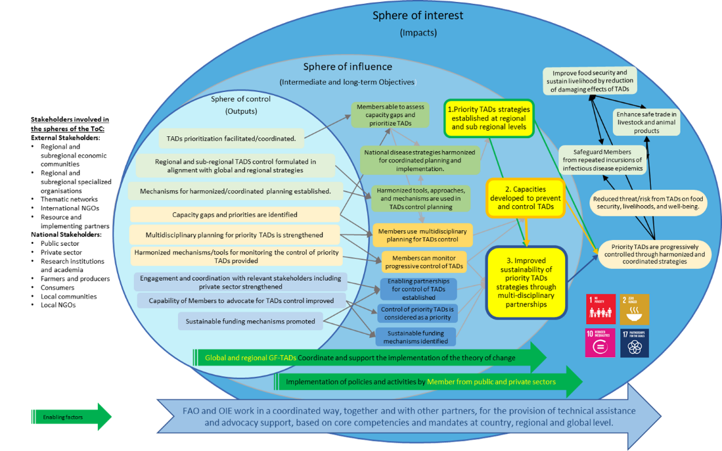

Please insert link to Global Action Plan
Such as WOAH PVS and FAO SAT
One full meeting, and a possible 2nd short meeting per year

